Lecture 2 (9/13/2023)



no quiz

today: Pandas

Homework 2:

if a classifier uses distance (kNN)

you need to scale your data

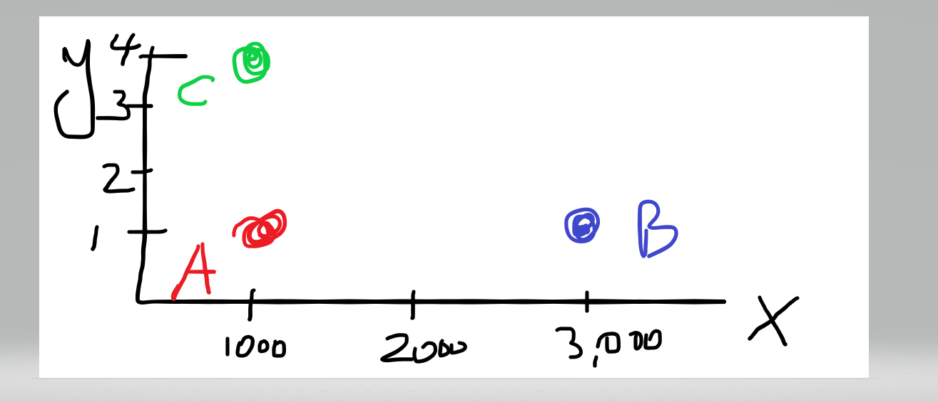

x = 1,2,5,8,9

y = 1400, 1800, 900, 750

min-max v -----🡪 (v – min(x))/(max – min)

min(x) = 1, max(x)= 9

range = 8

1 ------🡪 0; 2 --🡪 1/8, ….9 --🡪 1

z-scale ; x-🡪 (x-mean(X))/sigma